**Model Development Phase Template**

|  |  |
| --- | --- |
| Date | 12 JULY 2024 |
| Team ID | SWTID1720438678 |
| Project Title | Early prediction of chronic kidney disease. |
| Maximum Marks | 4 Marks |

**Initial Model Training Code, Model Validation and Evaluation Report**

The initial model training code will be showcased in the future through a screenshot. The model validation and evaluation report will include classification reports, accuracy, and confusion matrices for multiple models, presented through respective screenshots.

**Initial Model Training Code:**

**1. Logistic Regression**

**2. Decision Tree**

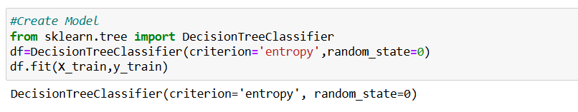

**3. Random Forest**

**4.SVM**

**Model Validation and Evaluation Report:**

|  |  |  |  |
| --- | --- | --- | --- |
| **Model** | **Classification Report** | **Accuracy** | **Confusion Matrix** |
| Logistic regression |  | 0.9875 |  |
| Random forest |  | 0.96 |  |
| Decision tree |  | 0.95 |  |
| SVM |  | 0.85 |  |